DRIVER DROWSINESS DETECTION SYSTEM
Anshul Chamoli, Bhavya Sharma, Sejal Anand
School of Computer Science
University of Petroleum and Energy Studies
Dehradun-248007, India

Abstract—In this paper, we attempt to build a driver drowsiness detection system, which is an automobile safety technology. Road accidents are unfortunate incidents that cause adverse damage to human lives and the drowsiness of drivers while driving. In the field of accident prevention systems, detection of drowsiness, that is a state near to sleep, at the wheel becomes a primary arena of focus. With long drive hours, lack of sleep and continuous driving can become tiresome leading to lack of attention and alertness of the driver. An intelligent system can be developed to prevent fatigue related accidents and the driver can be observed in real time to detect the facial features and process the input to detect for fatigue and generate an alert for the driver to prevent any unfortunate incident. The system of drowsiness detection can include three subsystems: acquisition system, processing system and warning system which work in a pipeline sequence to avert accidents.
Keywords: Driver drowsiness, machine vision system, face detection

INTRODUCTION
Sleep-divested driving, fatigue and use of medication cause deterioration in driver’s vigilance which can further lead to serious motor accidents. Additionally, an alternative reason for drowsiness can be dullness of driving on expressways or jam-packed traffic. According to a study [4], 21% of fatal accidents are caused by drowsiness in drivers and according to the estimates from the National Highway Traffic Safety Administration (NHTSA), driver drowsiness contributes to 100,000 traffic accidents annually. Accident prevention is a major challenge and development of technology provides us with advanced solutions to problems of road catastrophes. If the state of tiredness can be detected in a driver at an early stage, the driver can be alerted and accident can be averted. There are various methods including sensing physiological characteristics, driver operations, vehicle response and response of drivers which is dependent on expensive sensor and abundant data.
A machine learning approach can be used which helps in detection of drowsiness in driver and alerts the driver. A real-time machine-vision based system which detects the frontal face of the driver to identify tiredness given a driving environment can be developed which processes the captured image in multiple frames and generate appropriate response to the detection. A cost-effective and portable system is created by the suggested system, which uses machine learning and image processing to determine the level of driver drowsiness from facial photographs. Three subsystems make up the system, which is an automobile safety technology: an acquisition system, a processing system, and a warning system.
The current method includes three different types of general ways to identify drowsy driving: methods based on the vehicle, methods based on behaviour and methods based physiological factors. The steering wheel’s movement, the automobile’s accelerator or brake patterns, its speed, and any lane deviation are the factors dependent on the vehicle. Blinking, closing eyes, yawning, bending the head etc., are examples of visual behaviours whereas physiological signals like EOG, ECG, the heartbeat, EEG, pulse rate etc., are intrusive physiological methods to detect drowsiness [5].
A system that incorporates a real-time machine-vision based driver drowsiness detection is a low-cost and effective solution method for the problem of road-accidents which are caused by a drowsy driver, who may have slower reaction times, impaired judgment, and reduced awareness.

LITERATURE SURVEY
In this section, various works on detection of drowsiness in drivers are reviewed.
The study by Prajwal B S [1] proposed a system that is able to detect tiredness by watching the eyes. 68 face landmarks are used to identify significant facial characteristics. The facial landmarks that are identified to from face landmarks detection are provided as inputs to the system. In addition, a messaging-enabled alarm module is implemented. The goal of the effort is to reduce accidents and advance the technologies to prevent traffic-related fatalities.
Rohit Chinthalachervu et al. [2] developed a system for the detection of tiredness and sleepiness using the algorithms of machine learning and visual cues for behaviour such as Eye Aspect Ratio, Mouth Opening Ratio and Nose Length Ratio. By employing laptop’s webcam to record the video, these features are extracted from the threshold values and calculated. SVM and Bayesian classifier algorithms are employed in this case, and that performs the SVM perception, which is 0.569.
Jayasenan J. S et al. [3] introduced a system to localize the eyes and monitor fatigue was developed. The condition of the eyes, whether open or closed, can be determined by the monitoring. When the eyelids are closed for a prolonged amount of time, a warning signal is generated. Image processing provides a non-insidious way to detect tiredness without the annoyance and difficulty, and it achieves very exact and consistent drowsiness detection.
Following are some studies with the same goal of implementing driver drowsiness detection system to help reduce the accidents caused by fatigue in drivers.

DRIVER DROWSINESS DETECTION SYSTEM
Author: Rizul Sharma and Pratyush Agarwal
Summary: The author created a framework for the identification of driving drowsiness to stop accidents caused by driver fatigue and sleepiness The framework cognizant clients it addresses the concern of stressing out those with fatigue-related disorders by letting them know how sleepy they are when driving by making its arguments clear.

Driver Drowsiness Detection using Machine Learning Approach
Author: Priyanka Basavaraj Murdeshwar, Shruthi Tharanath Salian, Surekha Reddy Manjunath Kotari
Summary: To prevent drowsy driving-related incidents and help drivers maintain their alertness while operating the motor vehicle, the Driver Drowsiness Detection technology was created. This paper conducted its experiments in a room with intense, steady light. Additionally, there were many limitations, such as the darkness of skin and the lighting. The embedded system can used the Raspberry Pi 3 Model B and Raspberry Pi Camera together to assess the driver’s level of fatigue. A Raspberry Pi 3 Model B CPU determines whether a driver is sleepy or not.

Driver Drowsiness Detection Using Machine Learning
Author: Manoj Rode, Anirudh Bethi, Santosh Baddam, Bala Laxmi
Summary; The project has been designed in a way that is effective in identifying drowsiness and alerting drivers via an alarm sound to stop traffic accidents. In this, a model for drowsiness detection was trained using the Eye Aspect Ratio (EAR) technique using OpenCV, Keras, NumPy, and Pygame. With the help of OpenCV, they were able to acquire the video stream from a variety of sources, such as webcams and video files, and ascertain whether or not someone was drowsy. The model's results show a high degree of accuracy in determining whether or not the driver is sleepy. It is a noteworthy accomplishment that the model was able to reach performance accuracy of between 90 and 95 percent.

Driver Drowsiness Detection
Author: V B Navya Kiran, Raksha R, Anisoor Rahman, Varsha K N, Dr. Nagamani N P
Summary: The study compares studies on driver sleepiness detection and alarm systems in the article.. The following methodologies have been identified to drowsy state in drivers: PERCLOS, CAMSHIFT, HAAR and Voila Jones Algorithm. PERCLOS includes estimation of face pursuit, eye pursuit position, and estimation of the degree of eyelid closure. CAMSHIFT is founded on the idea of mean shift while the OpenCV library enables face and feature detection, with the ability to train classifiers to detect faces, which is known as HAAR training. Viola Jones algorithm uses HAAR based characteristics, integral picture generation, the AdaBoost algorithm, and a series of classifiers.

Driver Drowsiness Detection by Applying Deep Learning Techniques to Sequences of Images
Author: Elena Magan, M.Paz Sesmero, Juan Manuel Alonso-Weber, Araceli Sanchis
Summary: In this paper, Deep learning is a key component in both of the suggested implementations of a driver drowsiness monitoring system. In this study, a complete sequence of 60 s is used to assess a driver’s level of fatigue throughout the previous minute. Instead of determining whether or not motorist is fatigued from a single image, these systems use images of the driver to identify the fatigue symptoms. The first recommended method uses a deep learning model to merge a convolutional neural network and a recurrent neural network to predict the driver's level of fatigue. The second approach pre-processes the data using deep learning and artificial intelligence before using the fuzzy inference system to estimate the degree of fatigue.

Real-Time Driver Drowsiness Detection using Computer Vision

Author: Mahek Jain, Bhavya Bhagerathi, Sowmyarani C N
Summary: In this paper, The mouth and eyes are monitored by the model in order to detect tiredness. Important facial traits are identified using shape prediction techniques. Facial features identified using facial landmark identification serve as the inputs for these algorithms. Additionally deployed is an eSpeak When a motorist is feeling drowsy or yawning, a text to speech synthesiser module is employed to provide them the appropriate voice alerts.
Before the concept of image processing and machine-vision, the most common techniques to identify drowsy driving include vehicle-based, behavioural, and physiological techniques. The vehicle-based approach continuously monitors steering angle, acceleration, braking habits, and lane departure. Any difference in the data found may be the consequence of the driver's unpredictable behaviour. This is method is not sensor based and non-intrusive. The behaviour-based signals include head position, eye closure, and blinking rate which are examined and detected using sensors. Physiological-based methods rely on detecting changes in driver’s physiological states associated with drowsiness like heart rate, breathing rate, and electroencephalogram (EEG) readings. Vehicle-based methods are easy to implement, physiological-based methods can provide more accurate results while behaviour-based methods are non-invasive and easy to implement.

Issue in the existing system

i. Inaccuracy: Observing physical signs of drowsiness, such as yawning or drooping eyelids, may not always be accurate in identifying the level of drowsiness in a driver. Moreover, self-assessment by drivers may not always be reliable.
ii. Delayed response: The traditional system can result in a delayed response, as it relies on the driver to notice their level of drowsiness or for an observer to detect signs of drowsiness. This can result in accidents occurring before the driver's level of drowsiness is detected.
iii. Human Error: The traditional system is prone to human error, as it relies on the judgment and observation skills of an individual. Observers may miss subtle signs of drowsiness or may misinterpret them, leading to inaccurate assessments.

PROPOSED SYSTEM
We have come up with a driver drowsiness detection system which a nonintrusive machine vision based for monitoring a driver's vigilance in real time. This auto safety system uses machine learning to identify driver sleepiness and alert the driver via alarm sound. From a series of images from an acquisition system, it uses OpenCV to extract the face and Region of Interest (ROI), or eyes from sequences of images.

Reference Algorithm
The Eye Aspect Ratio (EAR) algorithm is a commonly used method for detecting eye blinks and determining the level of drowsiness of a person.

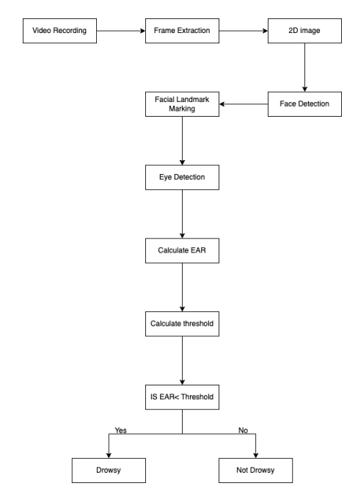Figure 1 Basic working of the proposed systems

The video is shot and collected using a camera in order to look for signs of sleepiness. It is suggested that the input be used to identify the driver's face initially. Locating facial markers on the human face, such as the eyes, mouth, and nose, comes next after faces have been detected. After marking the points on face, drowsiness features like Eye Aspect Ratio (EAR) are calculated. [2] A threshold value is defined based on the EAR value to distinguish between normal and drowsy states. Based on this value, it is determined if the driver is drowsy or not.

Eye Aspect Ratio

EAR (Eye Aspect Ratio) is a quantitative metric used in the proposed methodology to monitor driver drowsiness. When both eyes are given landmarks, the model guesses whether they are open or closed using the EAR algorithm [4]. From the boundary sites on the eyes, the EAR is calculated as the inverse ratio of eye width to eye height. The following is the EAR mathematical formula.

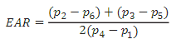
Where (i, j) denotes the distance between the two points, and "i" denotes the point designated as "i" in facial land marking. When the eyes are closed, EAR is approximately zero, and when they are open, it is maximum. Therefore, the EAR's declining value denotes the driver's drowsy behavior and the closing of their eyes[2].

Mouth Aspect Ratio
MAR (Mouth Aspect Ratio) is a measure of the width of an opened mouth. It is useful in identification of yawning of the driver [2]. It is given by ratio of distance between the corners of the mouth and distance between the upper and lower lips.
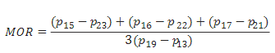
When the mouth is open, it is at its highest. For a specific amount of time, if the ratio stays nearly constant, yawning activity is present. When the ratio falls, the activity is deemed to not be yawning.

OpenCV
An open-source package called OpenCV (Open Source Computer Vision) offers a full collection of tools and algorithms for computer vision and image processing jobs. Since Intel first created it in 1999, it has grown to be one of the most well-known and widely used computer vision libraries. OpenCV provides a powerful and flexible set of tools for a wide range of computer vision tasks, from simple image processing to complex object detection and recognition.
Following are the ways in which OpenCV works:
- Image and video input/output: OpenCV can read and write a wide range of image and video formats, including popular formats like JPEG, PNG, BMP, and MP4.
- Image processing: OpenCV provides a variety of image processing functions such as image filtering, morphological operations, edge detection, and image segmentation.
- Object detection and recognition: OpenCV includes several pre-trained models for object detection and recognition tasks, such as face detection and pedestrian detection. These models can be trained on custom datasets for specific applications.
- High-level interfaces: OpenCV includes high-level interfaces for popular programming languages like Python, C++, and Java, making it easy to use for developers with varying levels of experience.

Requirements

System Requirements:
User Interface: The user interface of our project is a limited scope design that should be designed to provide clear and concise information to the driver, without being distracting or overwhelming while providing effective warnings to help prevent accidents caused by drowsy driving.
Software Interface: Implementation is in Python programming language that will execute in any system and an IDE for executing the code.
Database Interface: The interface shall allow real-time monitoring and data capture.
Protocols: HTTP/HTTPS request and response objects to send requests and download data from the web.

Non-Functional Requirements
Performance Requirements: The performance of the model is very much efficient and reliable. Even if there is a sudden spike in the number of students, the performance of the model wouldn’t be affected at all.
Security Requirements: The dataset isn’t stored in any database management system. Hence, it is not secured. The model’s security can’t be commented upon as in order to use the model’s features the user will have to set up their own environment on their systems of choice. The project files are hosted on GitHub and are publicly accessible.
Software Quality Attributes:
Usability: The usability of our model is very high allowing the end users to use our model easily.
Reliability: The reliability of our model is quite high as it is able to detect the frontal face and region of interest of an individual on the basis of acquisition of image captured.
Availability: It is easily available for every end user for the better detection of the tiredness in drivers.
Robustness: Our model is highly robust and effective as the code used for its development is really optimized.
Adaptability: The model developed is highly adaptive in nature. This means that the model can adapt to any changes if required in the future. For instance, if any new acquisition system is required for prediction, then we can easily link it our model and it can take that into consideration next time we use the model.
Portability: Our drowsiness detection project is developed in Python, a highly portable language that can run on a variety of operating systems like Linux, MAC and Windows, making it a simpler task to migrate the project between platforms. It also includes virtual environment tools and tools and dependencies for creating standalone executables, such as PyInstaller, enabling easy distribution and deployment. This allows us to execute our project on a variety of systems with no effort.
Testability: Whenever any changes are made in our code, it is tested to check whether the changes done are compatible or not. Testability prevents any errors during the time when the user is using our model

Assumptions and Dependencies
We make the following assumptions while developing the model:
1. We assume that the project won't pose any risks to the privacy or security of the user.
2. We make the assumption for the user's system to meet the prerequisites for executing the Python Code.
3. We assume that the hardware used like cameras, sensors for acquisition of the driver’s face are compatible with Python.

DESIGN
The design modeling represents the application components and help to develop the model effectively.

Data Flow Diagram
A data flow diagram uses a standardised set of symbols and notations to graphically depict the way data flow within a system. The goal is to illustrate the extent and bounds of a system as a whole. It demonstrates the methods through which data enters and exits the system, what modifies the data, and where data is kept. 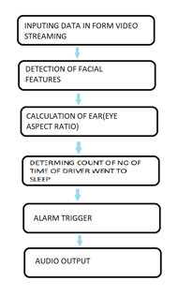
Figure 2 Data flow diagram of the proposed system

Use Case Diagram
The most popular kind of system/software requirements for freshly developed software programmes are use case diagrams. Use cases outline the expected behaviour (what), not the exact methods by which it will be accomplished (how). Use cases can be used to denote verbal and graphical representation (such as a use case diagram) once they have been defined. A crucial idea is the capacity of use case modelling to assist system design from the viewpoint of the end user. It is a valuable tool for users to understand system behavior. Since it describes all externally observable system behavior. Use case diagram does not only give details of the use cases:
• Only a few of the connections between use cases, actors, and systems are summarized.
• It does not display the progression of actions taken to fulfil each use case's objectives.
Purpose of Use Case Diagram:
• Takes the requirements of the system.
• It does drive implementation and make the test cases.
• It also confirms the architecture of the system.
• It also specifies the context of a system.
Use cases merely represent the functional requirements of a system. Other requirements, such as business rules, standards for service quality, and implementation constraints, must all be individually described using additional UML diagrams.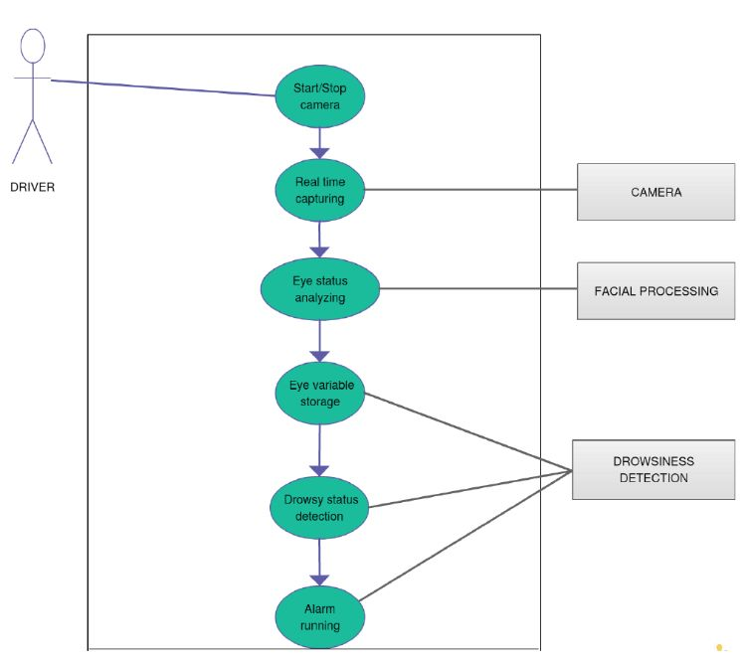
Figure 3 Use case diagram for the given model

Activity Diagram
Another crucial behavioral diagram in the UML used to depict the system's dynamic elements is the activity diagram. A more sophisticated version of a flow chart, an activity diagram models the transition from one activity to another. Activity diagrams show how multiple levels of abstraction of activities are coordinated to produce a service. A use case's events typically need to be accomplished by some operations, especially when those operations aim to achieve a variety of different goals that necessitate coordination, or how they relate to one another, especially in circumstances where activities may overlap and coordination is required. It is also useful to model how a collection of use cases interact in order to represent business operations.
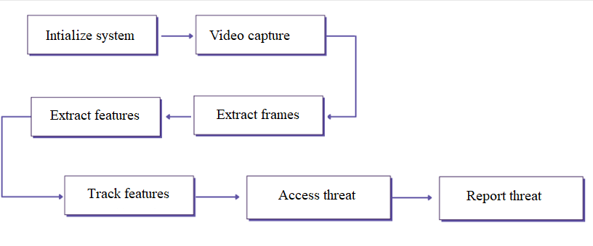
Figure 4 Activity diagram for the process flow of given model

Sequence Diagram
An interaction diagram that demonstrates the interactions and the sequence in which they take place between a collection of items is known as a sequence diagram. To comprehend the specifications for a new system or to define an existing technique, software developers and business professionals utilize these diagrams. Event scenarios and sequence diagrams are other names for these diagrams.
Purpose of sequence diagram:
• To see how to interaction takes place between the components and objects.
• To understand the functionality of the current and future things and understand them.
• Model the logic of a complex process, function, or method.
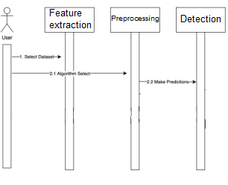
Figure 5 Sequence diagram for the drowsiness detection system

METHODOLOGY
The establishment of an advanced driving assistance system includes the detection of driver fatigue with the aim of alerting drivers to their tired state and reducing traffic accidents. It is crucial that non-intrusive tiredness detection in a driving scenario be used, and that the driver not be bothered by alarms when they are not sleepy.
The algorithm, Eye Aspect Ratio (EAR), assists in detecting eye blinks and determining the level of drowsiness of a person. It was first introduced by Soukupová and Čech in their paper "Real-time Eye Blink Detection using Facial Landmarks" in 2016. The EAR algorithm calculates the aspect ratio of the eye by measuring the vertical and horizontal distance between certain landmarks on the eye region of the face.
The input is taken as a video of the frontal face of a driver which maybe a live video. From the video frames, Face detection is done by OpenCV, followed by extraction of features of facial landmark including, eyes, mouth and nose. The Eye Aspect Ratio (EAR) is calculated using the detected eyes' positions, which is a ratio of vertical and horizontal distances between eye landmarks using the formula (|P2-P6| + |P3-P5|) / 2 * |P1-P4| where P1, P2, P3, P4, P5, and P6 are the landmark points corresponding to the eye region that can be used to determine whether a driver's eyes are open or closed. It is computed against a threshold value, which is defined on the basis of the EAR value to distinguish between normal and drowsy states. The value is compared against the threshold and if EAR is less than the threshold value, the driver is identified to be drowsy. This further generates an alarm to alert the driver of his drowsy condition.
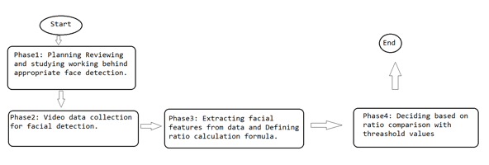
Figure 6 Proposed methodology for developing the model

RESULTS
The outcome compares the performance of the proposed drowsiness detection system on the test dataset
.
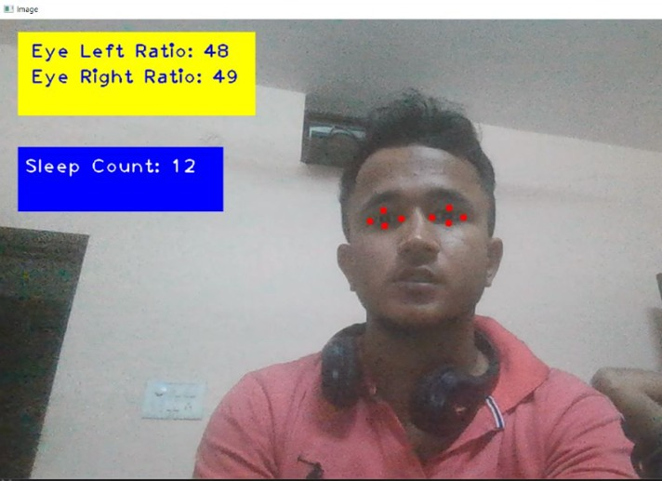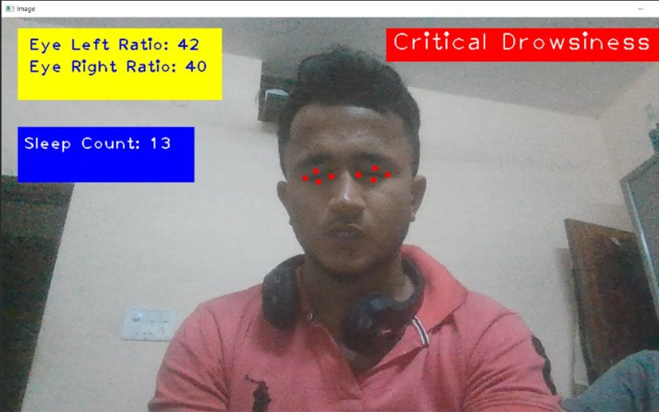

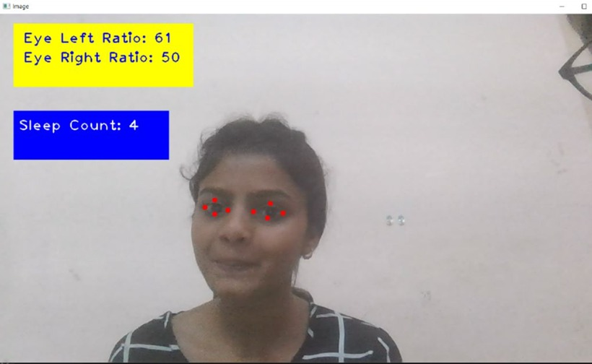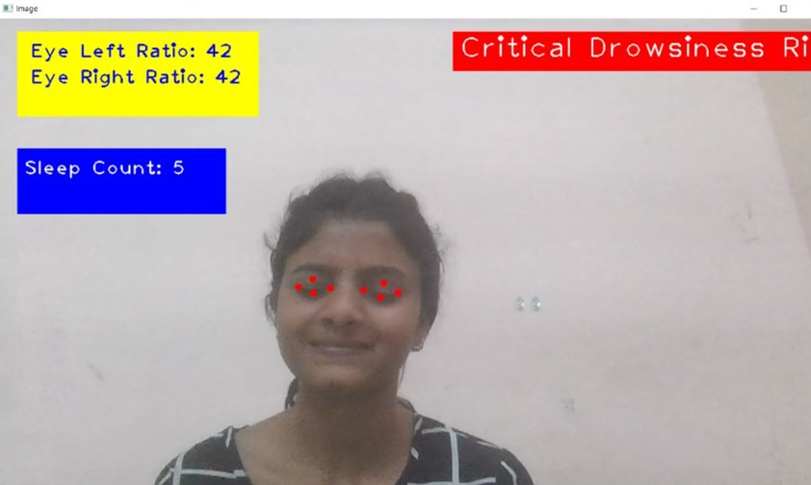
Figure 7 Test cases for the built system

CONCLUSION AND FUTURE WORK
A non-intrusive drowsiness detection system for drivers is built to identify fatigue and generate an appropriate response, in required cases. The system is built using simple algorithms and when compared to traditional methods of detecting fatigue proves to be more accurate. This initiative is to prevent road accidents caused by fatigue.
The outside factors, like sleeping time, weather conditions and mechanical condition of the vehicle, affecting exhaustion and drowsiness can be included in the future scope of the project.

REFERENECES
- B S, Prajwal. (2022). DRIVER DROWSINESS DETECTION. 10.13140/RG.2.2.28437. 40161.
- Chinthalachervu, Rohith & Teja, Immaneni & Kumar, M. & Harshith, N. & Kumar, T.. (2022). Driver Drowsiness Detection and Monitoring System using Machine Learning. Journal of Physics: Conference Series. 2325. 012057. 10.1088/1742-6596/2325/1/012057.
- S, Jayasenan & P S, Smitha. (2014). Driver Drowsiness Detection System. IOSR journal of VLSI and Signal Processing. 4. 34-37. 10.9790/4200-04113437.
- Rode, Manoj & Bethi, Anirudh & Baddam, Santosh & Laxmi, Bala & Kondaveti, Prasanna & Gadipally, Tejaswini & Katroth, Naresh. (2022). Driver Drowsiness Detection Using Machine Learning. International Journal for Research in Applied Science and Engineering Technology. 10. 10.22214/ijraset.2022.47516.
- IEEE Smart Grid Vision for Vehicular Technology: 2030 and Beyond," in IEEE Smart Grid Vision for Vehicular Technology: 2030 and beyond, vol., no., pp.1-65, 15 Jan. 2014, doi: 10.1109/IEEESTD.2014.6716939

